**Serial Communications I**

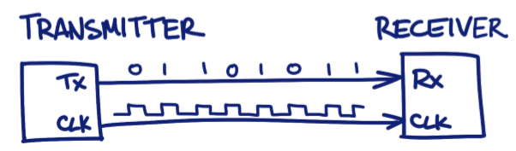**Serial Communications Basics**

* Transmit/receive data bits over a wire one bit at a time
* USB = Universal Serial Bus
* Need a clock signal
* Simplex, full duplex and half duplex

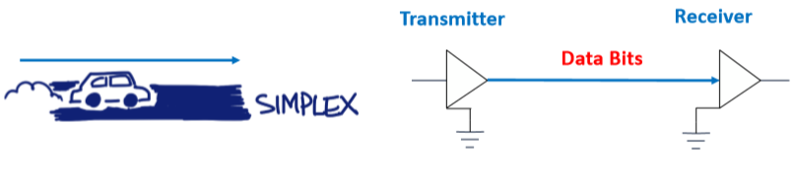**Simplex Transmission**

* 1 direction
* One wire and data transmission is unidirectional(1 direction)
* Transmit (Tx) buffer used at the transmitter
* Receive (Rx) buffer used at the receiver
* Data transmitted in packets

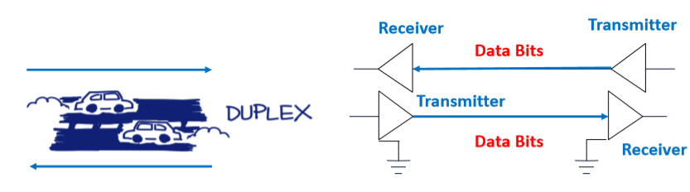**Full Duplex Transmission**

* 2 lanes
* data transmission – 2 direction simultaneously
* Tx and Rx – both ends

**Half Duplex Transmission**

* 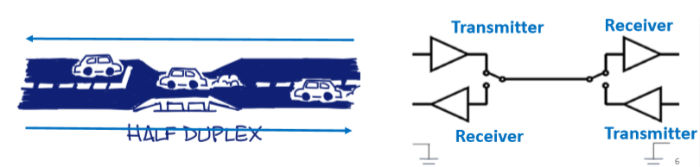need some direction protocol to allow one line to be one, not two.

**Serial Packet Structure**

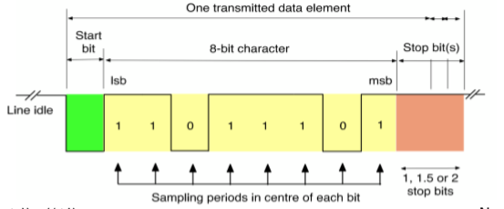Baud rate = number of bits that can be transferred in a second.

9600 **baud rate** = 9600 bits per second

Num of 1’s in data pkg + parity bit = Parity

data + parity bit = odd/even parity

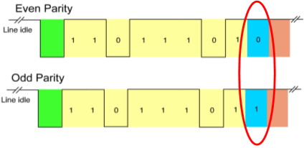**Parity Bit** (error correction coding)

* Optional – simple way to detect transmission error
* Even parity = number of 1’s in data byte (is even)
* Odd parity = number of 1’s in data byte (is odd)
* To fix it – resend byte or ignore packet

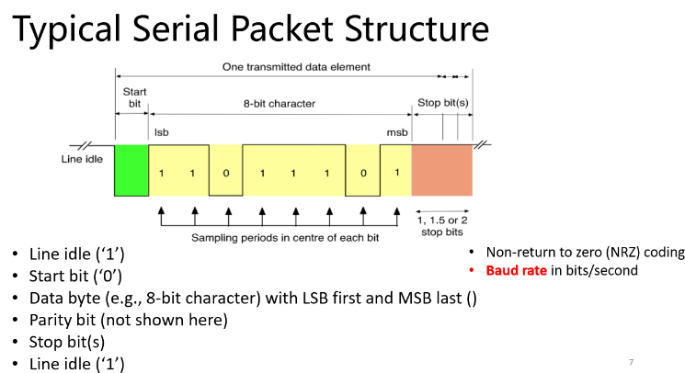**UART - on Tiva C-Series Launchpad**

UART = Universal Asynchronous Receiver Transmitter

* Usually full duplex
* 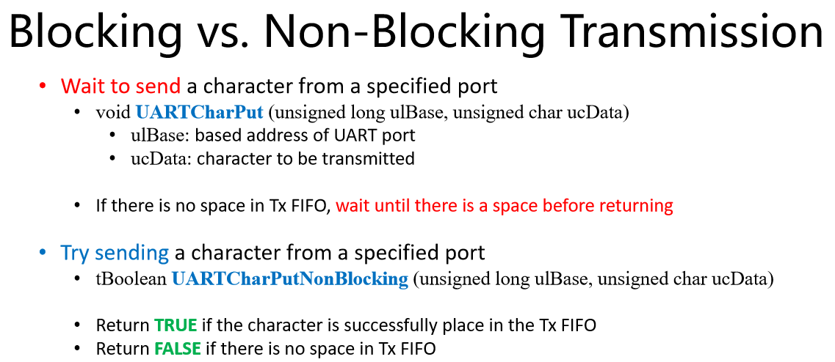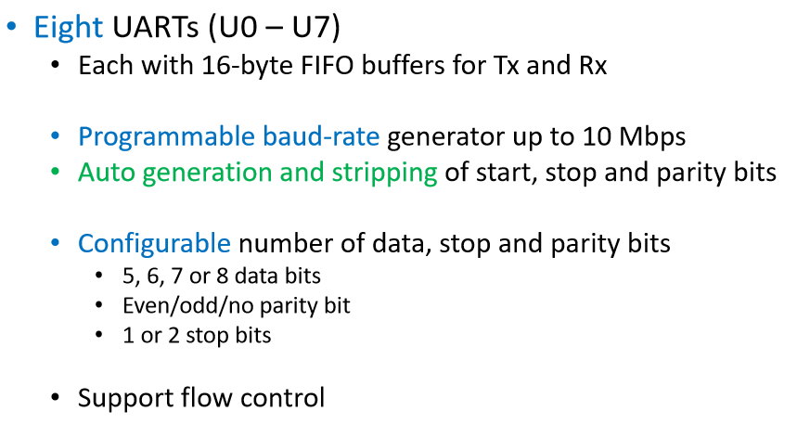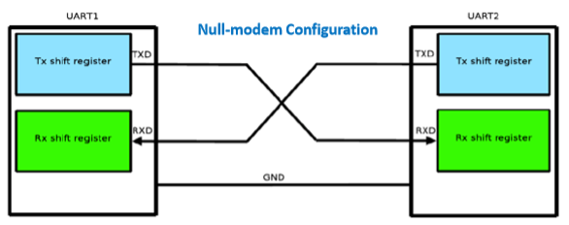8 UARTs (UO – U7)